XML/Web Services:
Web service is a way of communication or it is a technology it allows to develop interoperable distributed applications
Interoperability –Platform independent & Language independent
Java is platform independent but not language independent
Web services are not only strict on Java but also various languages like c, c++, .Net etc.
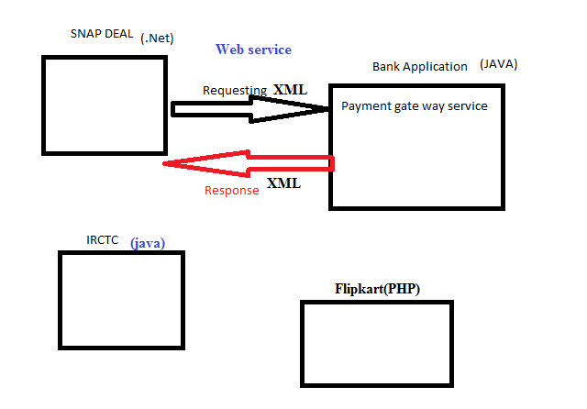
Distributed Applications- it is a server side application it exposes the objects over the network .in this ex- bank application is a server side application it exposes the payment gate way service object , those objects are accessing by some other applications on the network, it always exchanging the data or information over the network
Web Application- Server side application, web application is always communicate with the
Java🡪JSP, Servlets
PHP🡪PHP
.Net🡪ASP

Web service:
It is a distributed application
Languages 🡪 API
JAVA 🡪 Socket Programming API, CORBA, RMI, EJB API’s
.Net 🡪
C 🡪
C++ 🡪
WSI: Web services Interoperability
Open community .all the software companies are associated members so it’s common to all the languages and technologies

XML🡪
- Extensible mark-up language
- Mark-up: Enclosing the textual information between two tags i.e.; opening tag & closing tag.
Eg: <empName>raja</empName>
<empSalary>90000</empSalary>
- Here <empName>,<empSalary>🡪 Opening tag
- </empName>,</empSalary>🡪Closing tag
- HTML is also a Mark-up language
- Why XML is Extensible: XML tags are user defined tags. these tags can be extendable whenever required ,HTML tags are predefined
- Language: If you are design a web service application we need to design client & server application and the data should be communicate with client and server
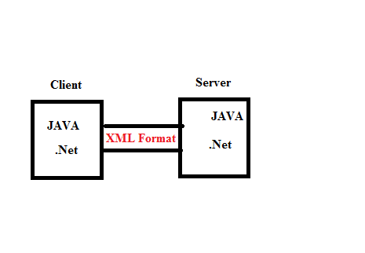
- XML is given by W3C is a common language .it can be understand ,by any type of programming language
- Interoperable language
  - Plat form Independent
  - Language Independent
- XML version is 1.0
- XML Documents possible to maintain text based databases
- XML document we are using to transport the data from one application to another

XML | HTML
Tags are user defined | Tags are predefined
Tags functionally defined by user and it is extensible | Limited
Case sensitive | Case insensitive
It describe the data | It displays the data
Every opening tag should maintain its closing tag | All the tags closing is optional
It is a mark-up language | It is also a mark-up language

Open Notepad🡪
<employee>
<empNo>1001</empNo>
<empSalary>90000</empSalary>
</employee>
Save with .xml extensible like p1.xml
How to view xml document
🡪Browser Software
🡪Editor Software

Output:
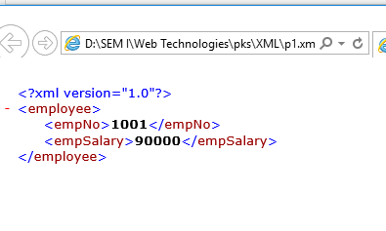

First line is prolog: it represent version of xml, XML documents are well defined documents, because some strict rules are available in this XML elements &documents.
If we do not follow the rules will not get proper XML document
XML documents contain:
- Elements
- Attributes
- Entity References
Elements:
- From opening tag to closing tag including text data called element
<employee>
<empNo>1001</empNo>
<empSalary>90000</empSalary>
</employee>
- From the above example there are 3 elements:
- employee
- empNo
- empSalary
- One element contain
  - Child elements
  - Attributes
  - Text data
  - Mix of all
Where & When to use an Attributes /Child Attributes:
- To define extra information of an element use child element or an attributes
Rules to write with Attribute:
Attribute values must be enclose with either single or double quotes
    - Eg:<employee empNo=101>🡪invalid
    - Eg:<employee empNo=”101”>🡪valid
    - Eg:<employee empNo=’101’>🡪invalid
- Attributes names are unique for one element
- Duplicate elements are not allowed in an element
- Attribute order is not important in an element

Entity References
- Syntax: &Entity-reference name ;
- Eg:
<Person >
<name>Abhi</name>
<age>The person age is <18</age >
</person>

- Output: is in valid
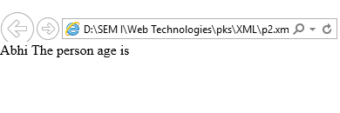
- Some special characters having some specialty ,so don’t give the in text , if we give it will invalid
- Following are the five predefined Entity references
  - & lt; 🡪<( lesser than)
  - &gt;🡪>(greater than)
  - &amp;🡪&(ampersand)
  - &apos;🡪’(single quotes)
  - &quot;🡪” “(double quotes)
- Eg:
<Person >
<name>Abhi</name>
<age1>The person age is &lt;18</age1>
</Person>

Output :
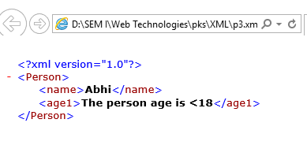

Well-formed XML Document
Rules:
- Must begin with PROLOG
- Must be maintain a unique root element
- Must be maintain closing tag for all the openings
- Write all the XML elements in a proper cases ,because the xml elements are case sensitive
- All the attributes & values we can enclose with either single quotes or double quotes
- In the place of some special characters we can use an entity references

DTD: Document Type Definition
- DTD is a XML technique use to define the structure of a XML document
- DTD is a text based document with .dtd extension
- It contains
  - Element declarations
  - Attributes
  - Entity References
- Element Declaration Syntax:
<! Element element-name (content Model)>
  - <!>🡪Declaration
  - Element🡪
      - Text data
      - Child Element
      - Empty Element
      - Mix of all
  - Element-name 🡪own choice
  - Content Model🡪 it specifies to allow the element
      - Text data
      - Child Element
      - Empty Element
      - Mix of all
Example of DTD:
< ! ELEMENT employee (empno, name, salary)>
< ! ELEMENT empno (#PCDATA)>
< ! ELEMENT name (#PCDATA)>
< ! ELEMENT salary (#PCDATA)>
Here PCDATA means Parser Character Data
XML:
<employee>
<empno>101</empno>
<name>raja</name>
<salary>12000</salary>
</employee>

- Here, XML elements are user defined and structure defined with dtd.
- In the above model five types elements declarations are possible
  - Text-only Element 🡪PCDATA
  - Child only Element
  - Empty Element
  - Any Element
  - Mixed Element
- Here,XML consider numbers, strings as text data
(3, 4, 5 will be explained in the cordiality concept)
How to link/map dtd to xml:
Use <! DOCTYPE > Declaration

Types of DTD’s:
- Internal DTD’s🡪write the dtd within the xml document
- External DTD’s🡪write the dtd in a suppurate text document & link with xml
Internal DTD: write the dtd within the xml document
Syntax: <! DOCTYPE root-element [DTD rules]>
XML Elements
Example:
<!DOCTYPE employee [
<!ELEMENT employee (empno, name, salary)>
<!ELEMENT empno (#PCDATA)>
<!ELEMENT name (#PCDATA)>
<!ELEMENT salary (#PCDATA)>
]>
<employee>
<empno>101</empno>
<name>raja</name>
<salary>80000</salary>
</employee>
(save this file with .xml extension)
Output:
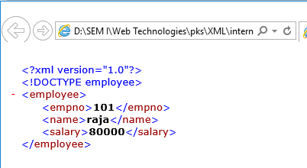

- Internal dtd’s are not reusable.
External DTD: write the dtd in a suppurate text document & link with xml
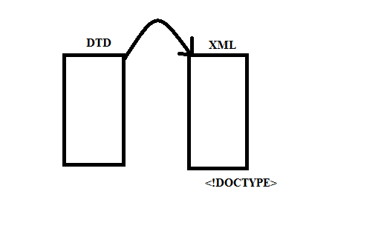

We can create External DTD’s in two ways
- Private DTD:

Syntax :<! DOCTYPE root-element SYSTEM”DTD FILE NAME .dtd”>

DTD file:
<!ELEMENT employee (empno, name, salary)>
<!ELEMENT empno (#PCDATA)>
<!ELEMENT name (#PCDATA)>
<!ELEMENT salary (#PCDATA)>
(Save this file with .dtd extension)
XML file

<! DOCTYPE employee SYSTEM”dtdfilepath.dtd”>
<employee>
<empno>101</empno>
<name>raja</name>
<salary>80000</salary>
</employee>
Output:
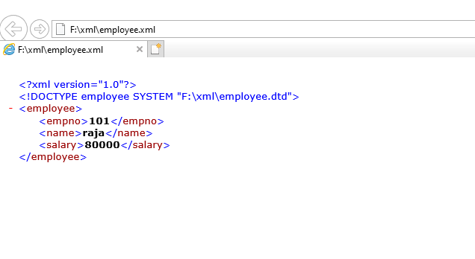
Differences between Internal, Private, and Public DTD’s:
Internal DTD | Private DTD | Public DTD
If any dtd is specific to a particular xml document is called Internal DTD | If any dtd is specific to a particular Project is called Private DTD | If any dtd is not specific to a particular Project but also common to all is called Public DTD  Eg: Hibernet,Spring framework

- Public DTD:
Syntax:
<! DOCTYPE root-element PUBLIC “-//vendorname//version//EN””dtdfilename.dtd”>
Here,
- indicate not registered with ISO
+ indicate registered with ISO
Vendor name, version, EN is not mandatory

DTD file:
<!ELEMENT employee (empno, name, salary)>
<!ELEMENT empno (#PCDATA)>
<!ELEMENT name (#PCDATA)>
<!ELEMENT salary (#PCDATA)>
(Save this file with .dtd extension)
XML file

<!DOCTYPE employee PUBLIC "-//jntuhces//1.0//EN" "F:\xml\Public DTD\employee.dtd">
<employee>
<empno>101</empno>
<name>raja</name>
<salary>80000</salary>
</employee>
Output:

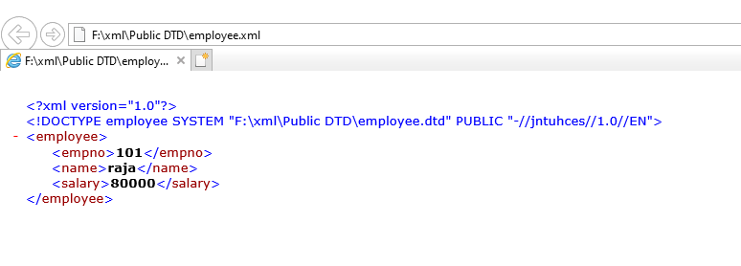

How to define child elements?
DTD File:
<!ELEMENT book (bookname , title)>
<!ELEMENT bookname (#PCDATA)>
<!ELEMENT title (#PCDATA)>
Here, in the above DTD book is the root element & book-name, titles are the child elements and, (coma) is the separator of the child elements in the first line)
XML File:
<!DOCTYPE book SYSTEM "D:\SEM I\Web Technologies\pks\XML\xml2\books.dtd">
<book>
<bookname>Core java</bookname>
<title> Core java</title>
</book>
Ouput: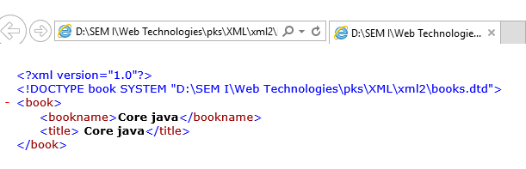
Here, child elements can also suppurate with vertical line (|),it indicates either-or
DTD File:
<!ELEMENT book (bookname|title)>
<!ELEMENT bookname (#PCDATA)>
<!ELEMENT title (#PCDATA)>
XML File:
<!DOCTYPE book SYSTEM "D:\SEM I\Web Technologies\pks\XML\xml2\booksvertical.dtd">
<book>
<bookname>Core java</bookname>
</book>
Output:
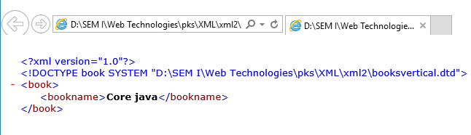

OR
<book>
<title> Core java</title>
</book>
Output:
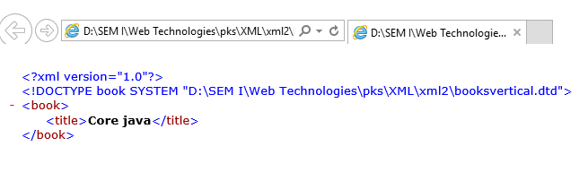

Cardinality: It specifies how many times an element can occur in an XML document
- ⃰ (star)represents 🡪 0 ton (Zero to Many)
- + (plus)represents 🡪 1 to n (One to Many)
- ?(question)represents 🡪 0 or 1 (Zero to One)

<!ELEMENT books(book)> 🡪Only 1 book element
<!ELEMENT books(book*)> 🡪0 or more book elements
<!ELEMENT>books(book-name|title,price,author+,publications?)>🡪either bookname or title,one price,1 to many authors,0 or 1 publications

Types of ELEMENTS:

Following are the possible elements in DTD
- Text only Element
- Child only Element
- Mixed Element
- EMPTY Element
- ANY Element

- Text only Element :
  - It allows only text data
  - Use PCDATA data type in the content model
    - Eg: <!ELEMENT empname(#PCDATA)>
    - Eg: <!ELEMENT empname(#PCDATA)>
- Child only Element:
  - It allows only child elements
    - Eg:<!ELEMENT employee(empname,empsalary)>
- Mixed Elements:
  - It allows Text data & child elements
    - Eg:
<employee>
Employee name is <empname>raja</empname>and
Employee salary is<empsalary>50000</empsalary>
</employee>
- EMPTY:
  - It won’t allows Text data ,child data but allows attributes
    - Eg:
<!DOCTYPE employees[
<!ELEMENT employees(employee*)>
<!ELEMENT employees EMPTY>
]>

- ANY:
  - It allows any data i.e.; text,child,mix,empty
    - Eg:
<!DOCTYPE employees[
<!ELEMENT employees(employee+)>
<!ELEMENT employees ANY>
<!ELEMENT empname(#PCDATA)>
<!ELEMENT empsalary(#PCDATA)>
]>
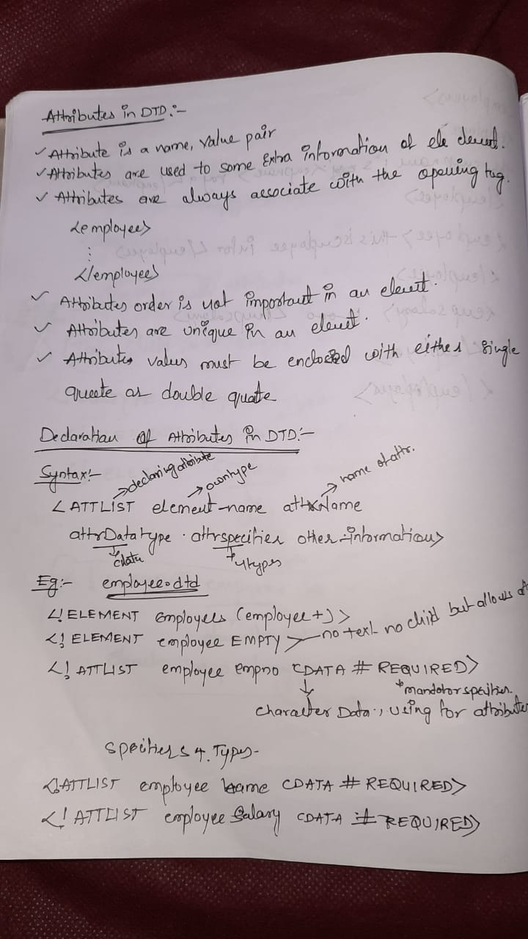
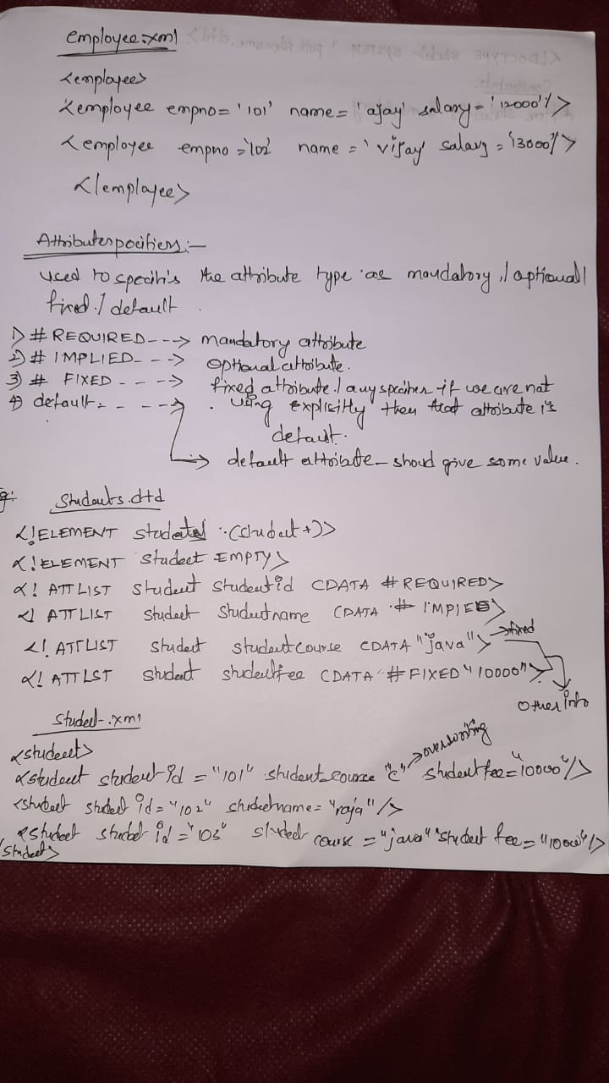
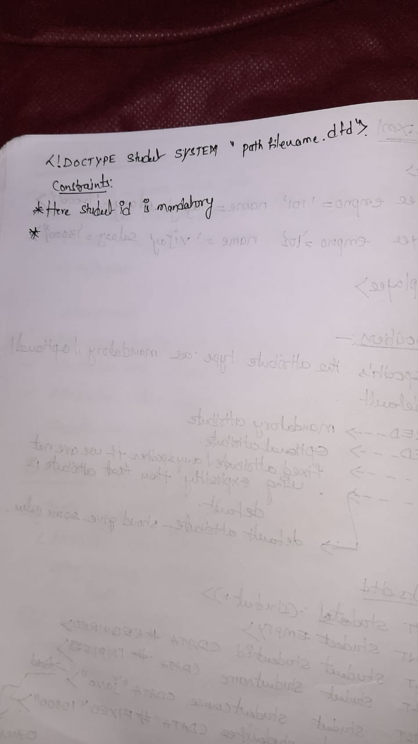
Attribute Data Types:
What type of data does want to allow for an attribute?
- CDATA
- ENUMERATED
- ID
- IDREF
- IDREFS
- ENTITY
- NOTATIONS
- NMTOKEN
- NMTOKENS
SYNTAX:
<!ATTLIST element-name attr-Name attr-Datatype attr-Specifier Other-information>

CDATA: It allows Character Data
<!ELEMENT employees(employee)>
<!ELEMENT employee EMPTY>
<!ATTLIST employee empno CDATA #REQUIRED>
<!ATTLIST employee empname CDATA #REQUIRED>
<!ATTLIST employee salary CDATA #REQUIRED>

ENUMERATED: It allows any one of the value from the specified list
How to give (value1|value2|value3)
<!DOCTYPE payments [
<!ELEMENT payments (payment+)>
<!ELEMENT payment EMPTY>
<!ATTLIST payment payment-type (DD|CHECK|CASH) #REQUIRED>
]>

<payments>
<payment payment-type="DD"/>
<payment payment-type="CHECK"/>
</payments>
OUTPUT:
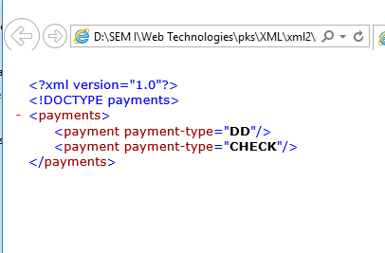

If you give payment type=”CARD “which is not available on the DTD specified list , then you get an error report (check below screenshot)

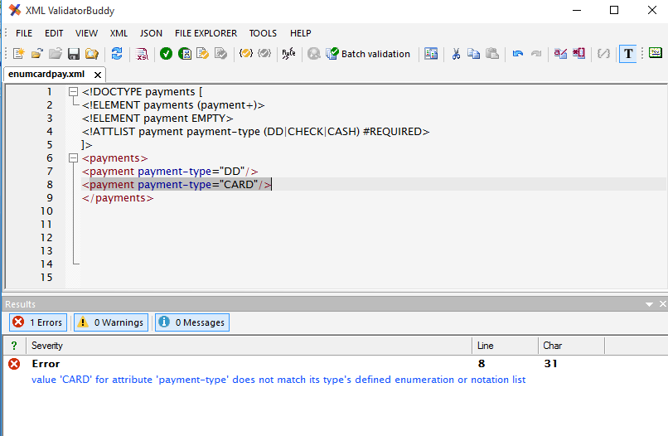
ID: It allows unique values and should not start with digit but we can start with _ (underscore)any alphabets(A-Z/ a-z)
<!DOCTYPE students[
<!ELEMENT students (student+)>
<!ELEMENT student EMPTY>
<!ATTLIST student sid ID #REQUIRED>
<!ATTLIST student sname CDATA #REQUIRED>
]>
<students>
<student sid=" jntuhces101" sname="Akhhi"/>
<student sid="jntuhces102" sname="Abhi"/>
</students>
OUTPUT:
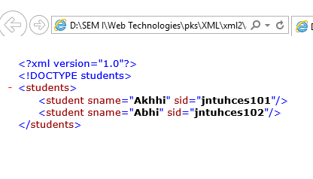

Here,
It allows unique values and should not start with digit but we can start with _(underscore)any alphabets(A-Z/ a-z),-(hifan),0-9
But dnt start with -
It does not allows $ symbol

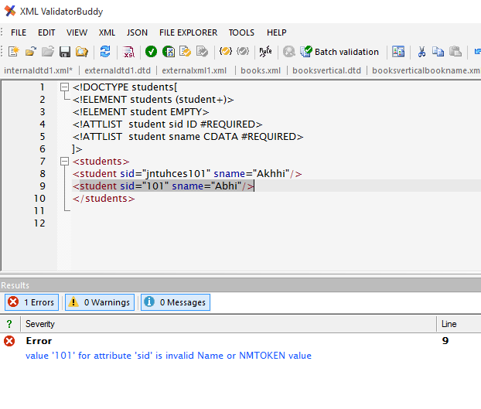

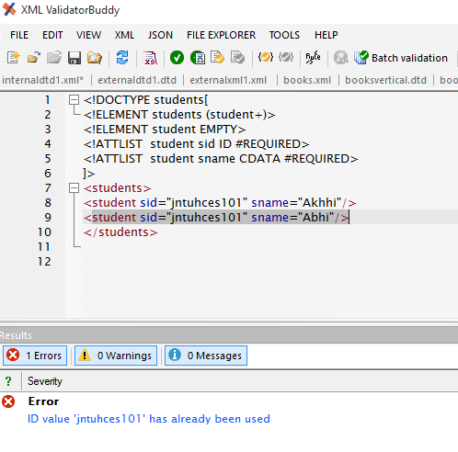

IDREF: It stores the value of some another ID element attribute
<!DOCTYPE students [
<!ELEMENT students (course*,student*)>
<!ELEMENT course EMPTY>
<!ATTLIST course cid ID #REQUIRED>
<!ATTLIST course cname CDATA #REQUIRED>
<!ATTLIST course cfee CDATA #REQUIRED>
<!ELEMENT student EMPTY>
<!ATTLIST student sid ID #REQUIRED>
<!ATTLIST student sname CDATA #REQUIRED>
<!ATTLIST student scourse IDREF #REQUIRED>
]>
<students>
<course cid="CJ201" cname="corejava" cfee="500"/>
<course cid="AJ202" cname="adjava" cfee="1500"/>
<course cid="S203" cname="spring" cfee="750"/>
<student sid="NIT101" sname="rama" scourse="CJ201"/>
<student sid="NIT102" sname="raja" scourse="AJ202"/>
</students>

OUTPUT: in the above ex cid="CJ201” value is referencing to scourse="CJ201"
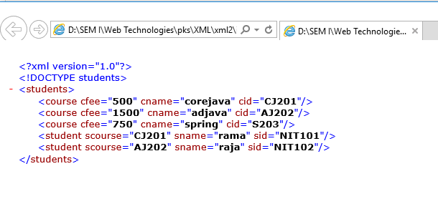

IDREFS: It stores the value of some another ID element attribute, referring list of values
<!ATTLIST course cfee CDATA #REQUIRED>
<!ELEMENT student EMPTY>
<!ATTLIST student sid ID #REQUIRED>
<!ATTLIST student sname CDATA #REQUIRED>
<!ATTLIST student scourse IDREF #IMPLIED>
<!ATTLIST student scourses IDREFS #IMPLIED>
]>
<students>
<course cid="CJ201" cname="corejava" cfee="500"/>
<course cid="AJ202" cname="adjava" cfee="1500"/>
<course cid="S203" cname="spring" cfee="750"/>
<student sid="NIT101" sname="rama" scourse="CJ201"/>
<student sid="NIT102" sname="raja" scourse="AJ202"/>
<student sid="NIT103" sname="ajay" scourses="CJ201 S203"/>
</students>
OUTPUT:
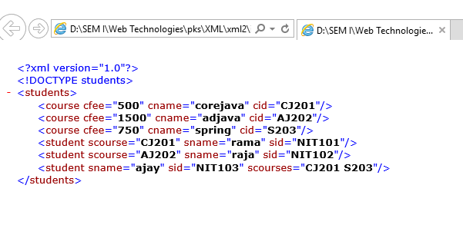

ID | IDREF | IDREFS
Attribute type value must be unique in the XML | Attribute stores some another element ID attribute type value | Similar to IDREF
Stores one value | Stores one value | Stores list of values

NMTOKEN: one of the type DTD, using to stores the attributes
If any attribute datatype is NMTOKEN the attribute always valid XMl , value must be valid XML means value contain alphabetical letters(A-Z),digits(0-9) special charcters - _ .
Will not allow the following special characters +? @#$
(NOTE-CDATA: It is similar to NMTOKEN but it contains more restrictions to accept the values, it can allows all NMTOKEN acceptable values and also +? @#$ )
EX:
<!DOCTYPE courses[
<!ELEMENT courses (course)+>
<!ELEMENT course EMPTY>
<!ATTLIST course cid ID #REQUIRED>
<!ATTLIST course cname NMTOKEN #REQUIRED>
]>
<courses>
<course cid="CJ201" cname="java"/>
<course cid="AJ202" cname="Advjava"/>
<course cid="C103" cname="c"/>
</courses>
OUTPUT:
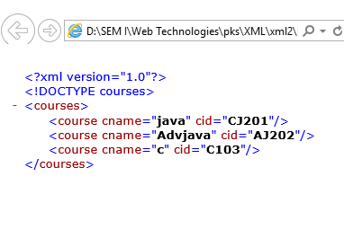
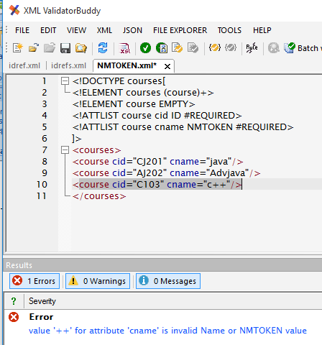

NMTOKEN | NMTOKENS
Always allows single value | Allows list of values

NOTATION: Is acting as shortcut to some specific types of media types
NOTE: Corresponding element content model should not be EMPTY
Ex: Represent photo type
<photo phototype=”image/jpeg”/>
<photo phototype=”image/gif”/>
image/jpeg🡪 jpg.
image/gif🡪gif
application/json🡪json
SYNTAX:
<!NOTATION NOTATION_NAME SYSTEM “IMAGE/JPEG”>
EX:
<!DOCTYPE photos[
<!NOTATION JPG SYSTEM "image/jpeg">
<!NOTATION GIF SYSTEM "image/gif">
<!ELEMENT photos (photo+)>
<!ELEMENT photo (#PCDATA)>
<!ATTLIST photo phototype NOTATION (JPG|GIF) #REQUIRED>
]>
<photos>
<photo phototype="GIF">This is mobile image</photo>
<photo phototype="JPG">This is nature image</photo>
</photos>
OUTPUT:
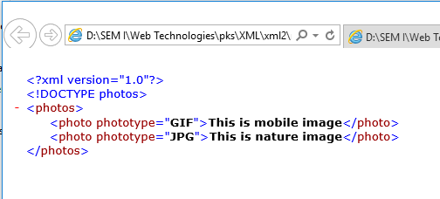
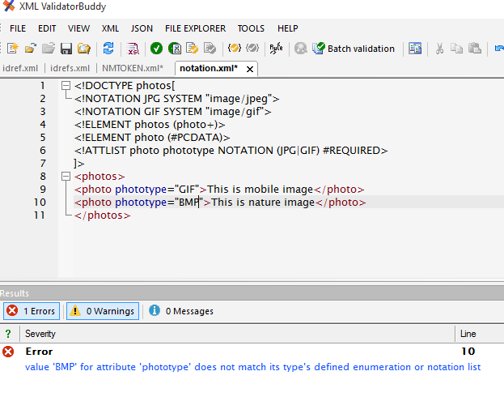

ENTITY: Is acting for a long length repeated string
Possible to use as Parsed (PCDATA), and unparsed (CDATA) data
Element content 🡪PCDATA
Attribute content🡪CDATA
ENTITY Creation for Parsed Content:
<!ENTITY entity-name “requiredvalues”>

<!ENTITY JNTUHCES “JNTUH COLLEGE OF ENGINEERING SULTANPUR”>
In the xml-------1000
&EntityReferenceName;
&JNTUHCES;
EX:
<!DOCTYPE courses[
<!ENTITY JNTUHCES "JNTUH College of Engineering Sultanpur">
<!ELEMENT courses (course*,inst*)>
<!ELEMENT course (#PCDATA)>
<!ELEMENT inst (#PCDATA)>
]>
<courses>
<course>B.Tech CEE</course>
<course>B.Tech CSE</course>
<course>B.Tech ECE</course>
<course>B.Tech MNT</course>
<inst>&JNTUHCES;</inst>
</courses>
OUTPUT
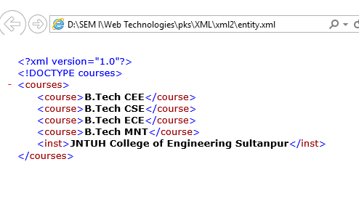

XSD:
XML Schema Definition, both XSD, DTD is used to define the structure of an XML document
DTD | XSD
- It is an XML technique to define the structure of an XML document | - It is an XML technique to define the structure of an XML document
- Old technique | - New technique
- Very less no of data types to restrict the data | - Many more data types to restrict the data
- Not allows to create our own data types | - It allows to create our own data types
- Three cardinality operators available here | - Many no of cardinality constants are available here
- It is possible to allow the elements following times 0-N,1-n,0-1 | - Here it can also supports 0-5,5-10,10-15
- It doesn’t having any namespace concepts | - But it has namespace concepts
- Only PCDATA is using for element declaration

Name space discussion
Package com.jntuhces.service;
Public class AccountService {
:
:
:
}
Class Test {
P S V main(string[] args){
Com.jntuhces.serive.AccountService a;

If there is fully classified services there are no ambiguity problems

Ex:
Class Test{
P s v main (String[] args){
Java.util.Date.d1;
Java.sql.Date.d2;
}
}
If no packages in java will ambiguities, similarly namespace also created in XML
Like c🡪library functions
Java🡪packages
.Net🡪namespaces
XSD🡪namespaces
Data Types:
- Simple Types

  - Built in Types (44)
    - Primitive Types(19)
String, Boolean, decimal, float, double, duration, datetime, time, date,
gYearMonth, gYear,gMonthDay,gDay,gMonth,hexbinary,base64Binary,anyURI, QName, NOTATION
    - Derived Types(25)
NormalizedStrings,token,language,NMTOKEN,NMTOKENS,Name,NCName,ID,IDREF,TDREFS,ENTITY,ENTITIES,integer,nonpositiveInteger,negitiveInteger,long,Int,short,byte,nonNegitiveInteger,unsignedLong,unsignedInt,UnsignedShort,unsignedByte,positiveInteger.
  - User-derived Types
    - Atomic Types
    - Non-Atomic Types
- Complex Types
  - EMPTY
  - Simple Content
  - Complex Content
    - Sequence
    - Choice
    - All

XSD Elements:
Simple Elements: If any elements contains only the text data is called Simple Element , doesn’t contain child elements, attributes
<empNO>101</empNo>
<name>raja</name>
Syntax:
<element name=”element-name” type=”data type”>
</element>
Ex:
<element name=”empNo” type=”int”/>
<element name=”name” type =”string”/>

Complex Elements: It allows Text data and it contains child elements or attributes or both
<employee>
<empNO>101</empNo>
<name>raja</raja>
</employee>

Here, <employee>is a Complex element,<empNo>,<name> are the child elements

      - Elements with Text-Data and Attributes
      - Elements with Empty Content and attributes
      - Elements with Child Elements And/OR attributes
      - Elements with Mixed Content And/OR attribute

1st Way: A Complex Element with Child Element
<schema>
<element name=”element-name”>
<complexType>
<sequence>
<element name=”child1” type=”dt”/>
<element name=”child1” type=”dt”/>
----
-----
</sequence>
</complexType>
</element>
</schema>
In this Complex Elements use any one of the data type of complex content data types.

EX:
XSD:
<schema>
<element name=”employee”>
<complexType>
<sequence>
<element name=”empNo” type=”int”/>
<element name=”name” type=”string”/>
<element name=”salary” type=”decimal”/>
</sequence>
</complexType>
</element>
</schema>
XML:
<employee>
<empNo>101</empNo>
<name>raja</name>
<salary>9000</salary>
</employee>

XSD Attributes Declaration

Syntax:
<attribute name=”attribute-name” type=”attribute-type”/>
Ex:
<attribute name=”courseId” type=”int”/>
<attribute name =”courseName” type=”String”/>
<attribute name =”courseFee” type=”decimal”/>
Attribute Declaration:
Mandatory Attribute:
<attribute name=”courseId” type=”int” use = “required”/>
Optional Attribute:
<attribute name=”courseId” type=”int” />
Default Attribute:
<attribute name=”courseName” type=”string” default=”java”/>
Fixed Attribute:
<attribute name=”courseFee” type=”decimal” fixed=”1000”/>

In XSD complex Type with Attributes:
<schema>
<element name=”course”>
<complexType>
<attribute name=”courseId” type=”int”/>
<attribute name =”courseName” type=”String”/>
<attribute name =”courseFee” type=”decimal”/>
</complexType>
</element>
</schema>

In XML:
<course courseId=”101” courseName=”java” courseFee=”2000”/>
Complex Type Elements
- Elements with Child Elements And/or Attributes
- Elements with Mixed Content And/or attributes
- Elements with Text-Data and attributes
- Elements with Empty Content and attributes

            - Elements with Child Elements
<schema>
<element name=”employee”>
<complexType>
<sequence>
<element name=”empNo” type=”int”/>
<element name=”name” type=”string”/>
<element name=”salary” type=”decimal”/>
</sequence>
</complexType>
</element>
</schema>

            - Elements with Mixed Content
<schema>
<element name=”employee”>
<complexType mixed=”true”>
<sequence>
<element name=”empNo” type=”int”/>
<element name=”name” type=”string”/>
<element name=”salary” type=”decimal”/>
</sequence>
</complexType>
</element>
</schema>

XML:
<employee>
The EmpNo is <empNo>101</empNo>
And Name is <name>Sagar</name>
And salary is <salary>2000</salary>
</employee>

            - Elements with Text-Data and Attributes
<schema>
<element name=”employee”>
<complexType >
<simpleContent>
<extension base =”string”>
<attribute name=”empNo” type=”int”/>
<attribute name=”name” type=”string”/>
</extension>
</simpleContent>
</complexType>
</element>
</schema>

XML:
<employee – (attributes here)------>
This is jntuhces emplpoyee
<employee>

Note: <restriction>, <extension > both are using for data types.

            - Elements with Empty Content and Attributes
<schema>
<element name=”course”>
<complexType >
<element name=”courseId” type=”int”/>
<element name=”courseName” type=”string”/>
<element name=”courseFee” type=”decimal”/>
</complexType>
</element>
</schema>
XML:
<course courseId=””>
courseName =””
courseFee=””/>

XSD Namespace Concept:
In java package conceptis used to group all the classes as a single unit.
Whenever a class is present in a package at the time of using of that class we will usefully qualified names.
Fully qualified name means class Name along with its package Name
If we are using fully qualified names it is possible to avoid some kind of ambiguity problems

Class Test{
Java.util.Date.d1;
Java.sql.Date.d2;
}
}
In XSD Namespace Concept namespaces are used to group all the elements as a single unit.
At the time of using the element we will use fully qualified name
Here fully qualified name means NameSpace+ElementName

Java-Package packageName;
For one .java file only one package declaration statement possible to use
XSDtargetNamespace

